1. Top 10 countries that use Krikey
   1. Based on the data analysis, the Krikey app is most popular in 4 major countries.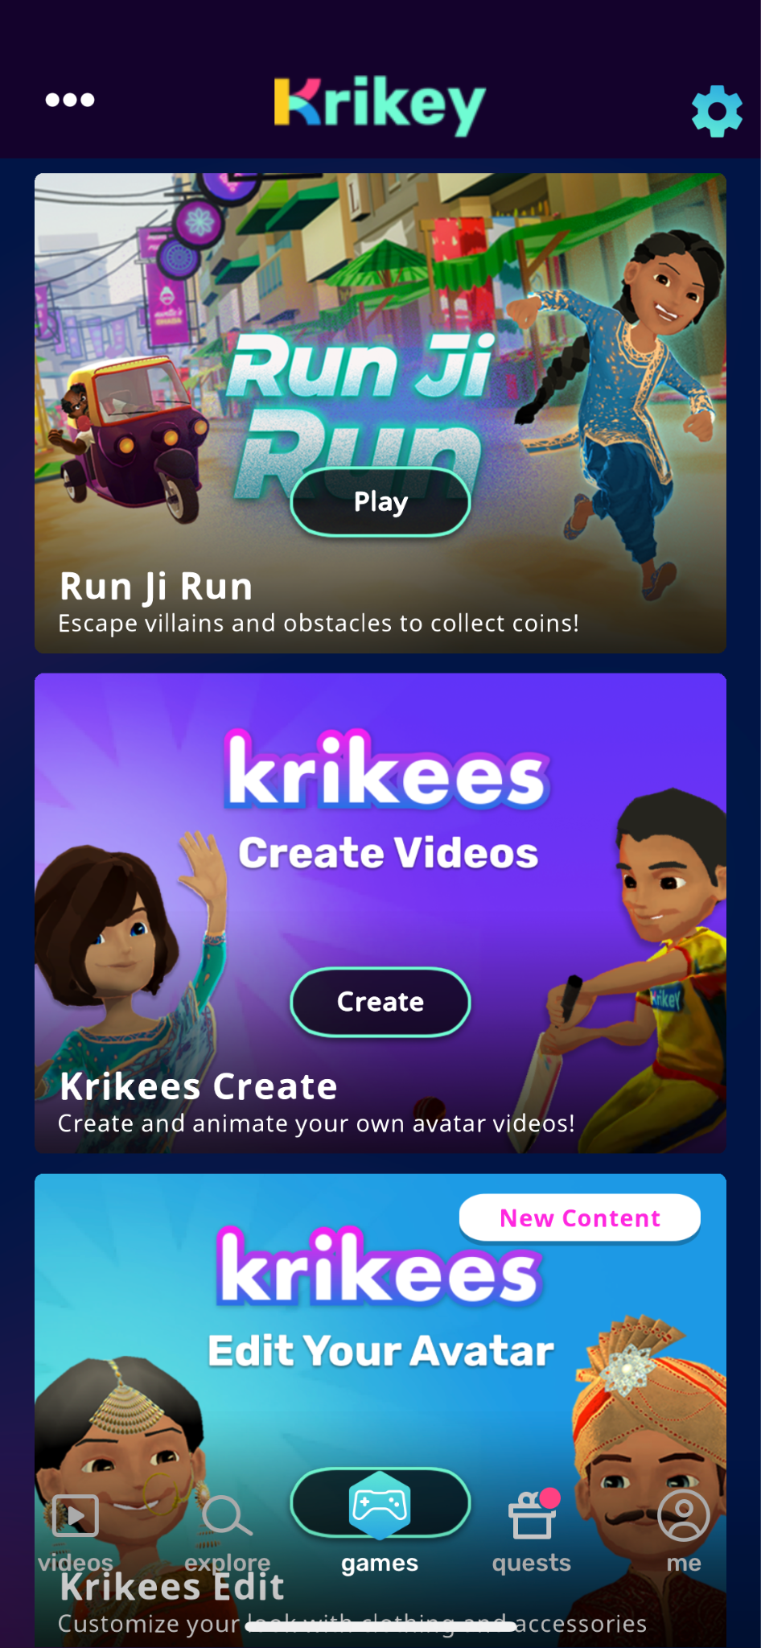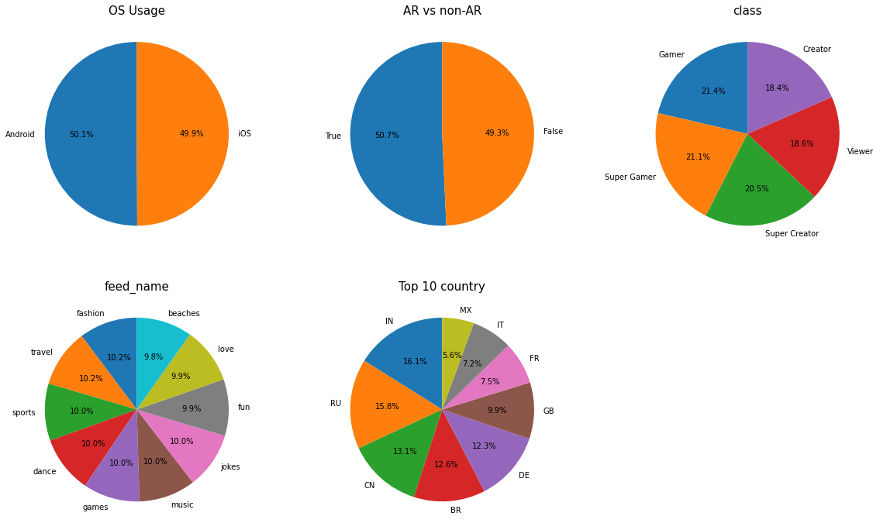

Suggestion: Develop games with more

countries as background and shows

locally related games on the top list

depending on the user’s location and profile

1. Watched video duration is highly correlated to video duration 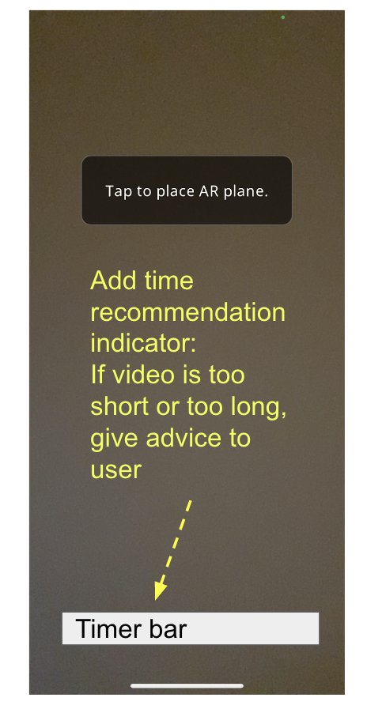

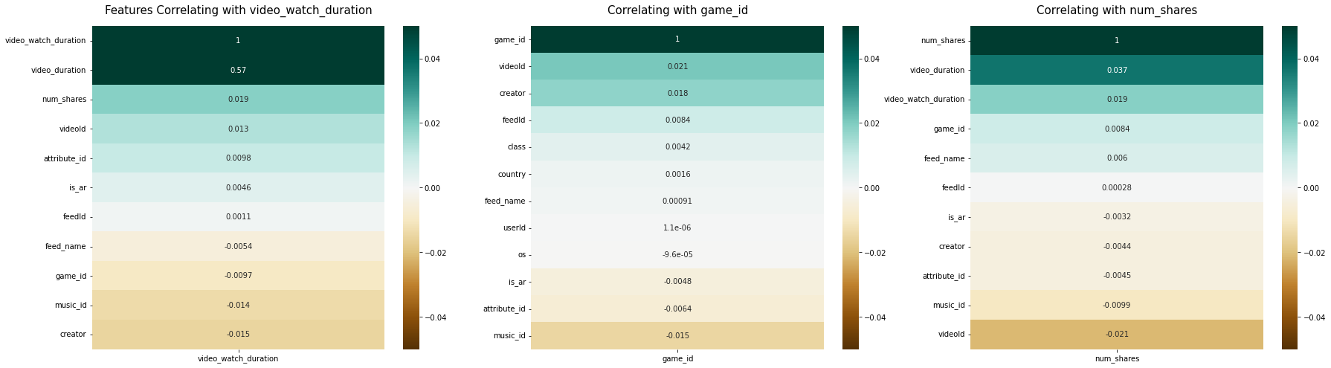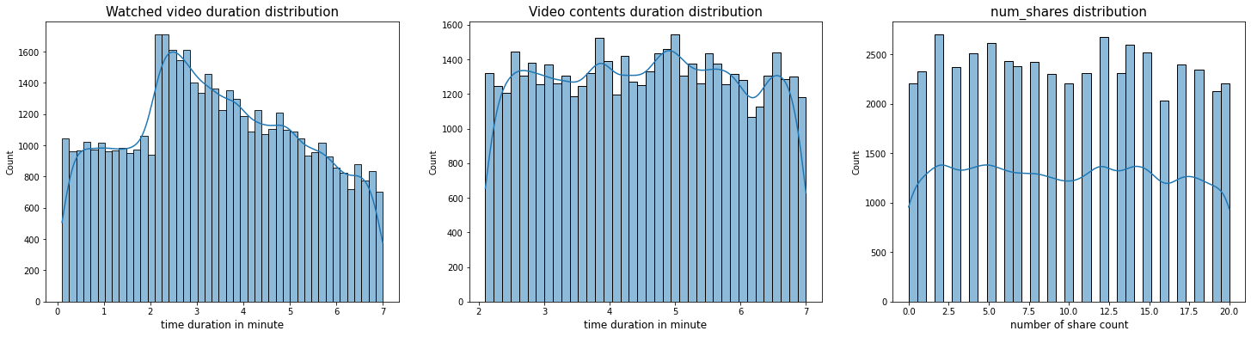

1. Recommend music and games per user
   1. Music and games are correlated with Video. Krikey can add a recommendation feature to the product depending on what videos are watched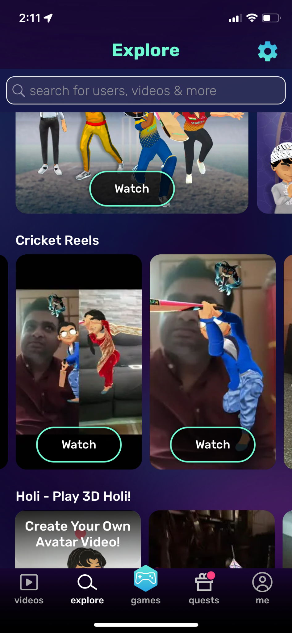

* Recommend games and music to users when users browse

certain video clips or create videos

(see right side app screenshot)

